data stuctures – ASSIGNMENT 1
- Name: Nethra Haridass
- Reg. no.: 1921260111
- Course code: CSA0304
- Course name: Data Structures

1. Structure in C and its role in data stuctures
ANS:
Definition of Structure in C
A structure in C is a user-defined data type that allows the grouping of different types of data under a single name. It is declared using the keyword struct. A structure can contain different data types, such as integers, characters, floating-point numbers, and arrays.
Structures help organize related information into a single unit, making data easier to store, access, and manage. For example, a student record may contain a student's name, roll number, age, and marks. These details can be grouped together using a structure

Role of Structures in Data Structures
Structures play an important role in implementing various data structures in C. They help organize data efficiently and represent complex relationships between data elements.

1. Grouping Related Data
Structures allow different types of related information to be stored together. This makes programs more organized and simplifies the management of data. For example, student details such as name, roll number, and marks can be grouped into one record.

- Creating Records
Structures are useful for representing real-world entities such as students, employees, books, and products. Each structure can store multiple attributes belonging to a particular entity, making information easier to access and maintain.

3. Implementing Linked Lists
Structures are widely used to create nodes in linked lists. Each node contains data and a pointer that stores the address of another node. This allows multiple nodes to be connected, making it possible to insert, delete, and traverse elements efficiently.

4. Representing Trees and Graphs
Structures are used to represent nodes in trees and graphs. In a tree, a node can contain data and pointers to its child nodes. In a graph, structures can represent vertices and their connections. This helps in organizing hierarchical data and representing relationships between different elements.

5. Improving Data Organization
Structures improve the readability and maintainability of programs by grouping related information logically. They also make it easier to pass related data between functions and manage large amounts of information.

Advantages of Structures in C:
- They combine different data types into a single unit.
- They improve data organization and program readability.
- They support the implementation of complex data structures.
- They simplify the storage and management of records.
- They make programs easier to maintain and modify.

2. Compare memory usage of recursion vs iteration
ANS:

Recursion and iteration are two methods used in C programming to solve problems by repeating a set of operations. However, they differ in the way they use memory. Recursion occurs when a function calls itself repeatedly until a base condition is reached, whereas iteration uses loops such as for, while, or do-while to repeat instructions until a condition is satisfied.

Memory Usage in Recursion

Recursion generally requires more memory because every recursive function call creates a new stack frame in memory. Each stack frame stores information such as local variables, function parameters, and the return address. These frames remain in memory until the recursive calls are completed. As the depth of recursion increases, memory usage also increases. For example, when calculating the factorial of a number using recursion, each function call waits for the next call to return its result. Therefore, the function call stack grows with the number of recursive calls. In general, recursion requires O(n) auxiliary space when the recursion depth is proportional to n. If the recursion becomes too deep, it may cause stack overflow.

Memory Usage in Iteration

Iteration generally requires less memory because it uses loops to repeat instructions without repeatedly calling a function. It usually stores only a few variables, such as counters and temporary values, to perform calculations. For example, when calculating the factorial of a number using a loop, the program can store the result in a single variable and update it during each iteration. Therefore, the memory usage remains constant as the number of iterations increases, provided that no additional memory is allocated. In this case, iteration requires O(1) auxiliary space, making it memory-efficient.

Comparison Between Recursion and Iteration
The main difference between recursion and iteration is their memory consumption. Recursion uses additional stack memory for each function call, whereas iteration generally uses a fixed amount of memory. Recursion is often easier to understand when solving problems involving trees, graphs, and divide-and-conquer techniques. However, iteration is usually more memory-efficient for simple repetitive calculations. Recursion may also cause stack overflow if the recursion depth becomes too large, while iteration avoids this particular problem.

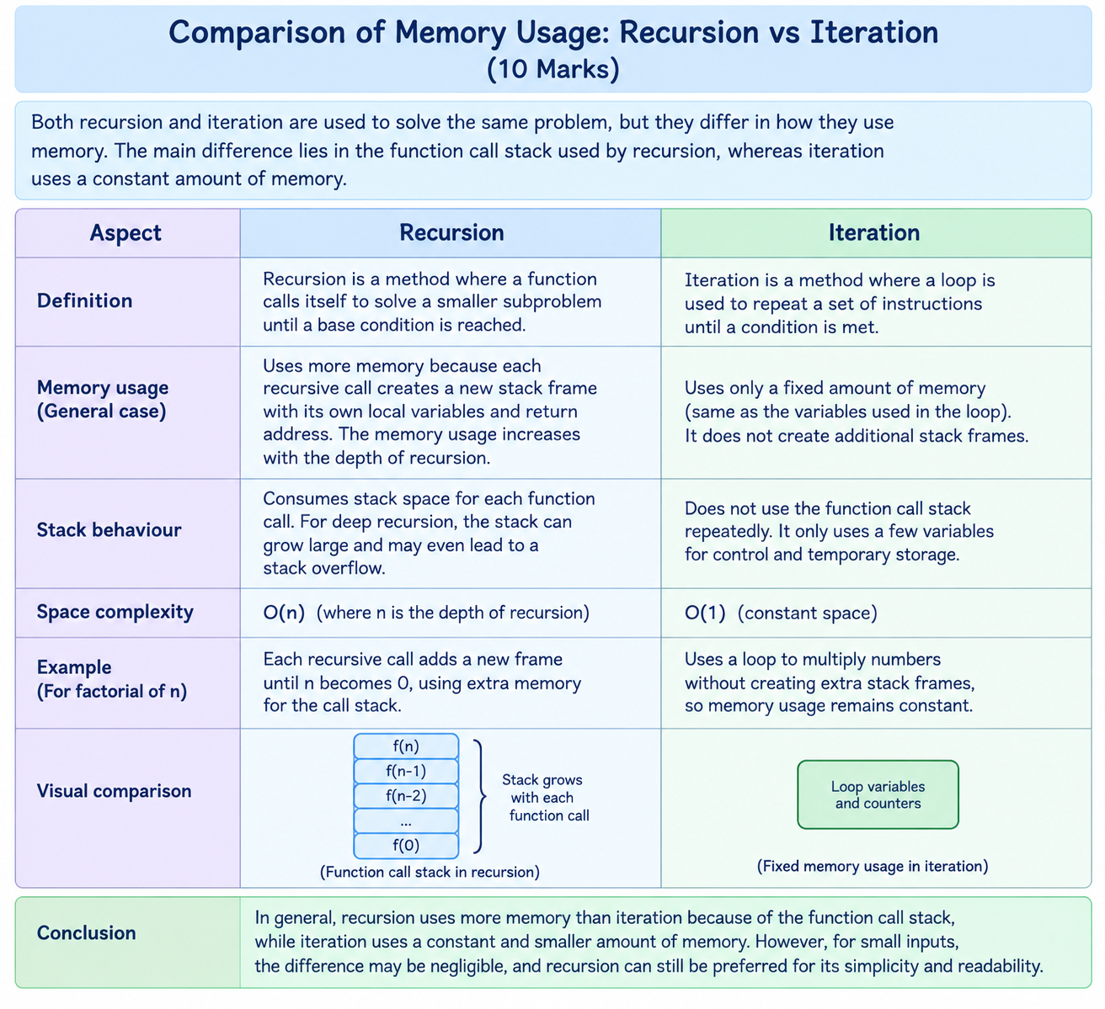

3. Explain the use of linear structure in scheduling system
ANS:
Linear data structures are used in scheduling systems to organize and manage tasks in a specific order. A linear data structure stores elements sequentially, where each element is arranged one after another. The commonly used linear data structures in scheduling systems are queues, priority queues, and linked lists.

1. Queue
A queue follows the FIFO (First In, First Out) principle. The task that arrives first is executed first. It is used in printer scheduling, customer service systems, and process scheduling.

2. Priority Queue
A priority queue assigns a priority to each task. Tasks with higher priority are executed before tasks with lower priority. It is used in operating systems to manage important processes.

3. Linked List
A linked list stores tasks as connected nodes. It allows tasks to be added or removed easily. It is useful in managing processes and maintaining scheduling lists.

4. Stack
A stack follows the LIFO (Last In, First Out) principle. It is useful for managing function calls and tracking tasks that need to be completed in reverse order.

5. Advantages in Scheduling Systems
- Organizes tasks efficiently.
- Helps manage task execution order.
- Makes insertion and deletion of tasks easier.
- Supports process management in operating systems.
- Improves task handling and resource utilization.

-------------THANK YOU------------

